|  |  |
| --- | --- |
| Good Places **🗸** | See the source imageBad Places |
| Think of places that are safe to walk/cross;  For example: *A well-lit pavement in the evening,*  *where you are visual to cars* | Think of places that are unsafe to walk/cross  For example: *Underpass in the evening,*  *on a bend* |

Practical Exercise

Cut out and stick these photos to show what you think are good or bad places to cross

[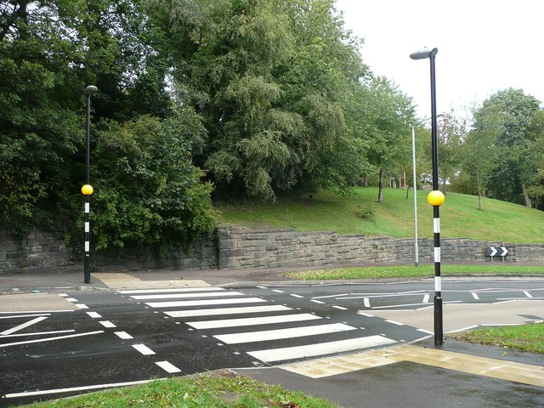](http://www.google.co.uk/url?sa=i&rct=j&q=&esrc=s&source=images&cd=&cad=rja&uact=8&ved=2ahUKEwir_K77zb7aAhXHuhQKHaxYAbQQjRx6BAgAEAU&url=http://www.geograph.org.uk/photo/2640706&psig=AOvVaw0LKtT39rA5uD0TlVumWQR6&ust=1523961712959127)

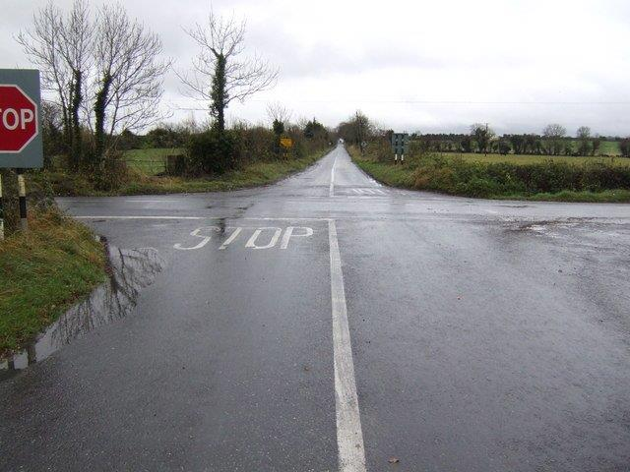[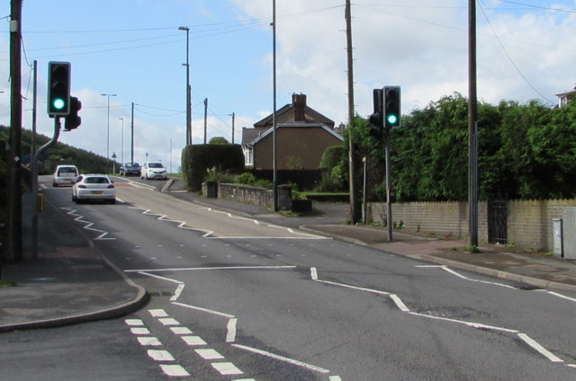](https://www.google.co.uk/url?sa=i&rct=j&q=&esrc=s&source=images&cd=&cad=rja&uact=8&ved=2ahUKEwiHyfnFzr7aAhUFXBQKHbHMDroQjRx6BAgAEAU&url=https://www.geograph.org.uk/photo/5647149&psig=AOvVaw1L6rWToC7711Wp1sijjjIS&ust=1523961849464715)

[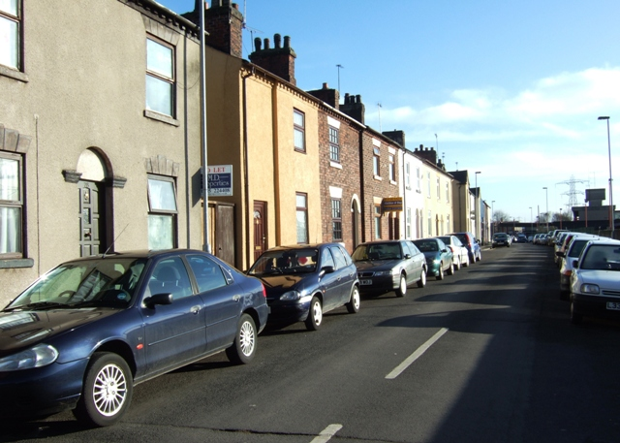](http://www.google.co.uk/url?sa=i&rct=j&q=&esrc=s&source=images&cd=&cad=rja&uact=8&ved=2ahUKEwi784-c0b7aAhWKcRQKHXlvBjgQjRx6BAgAEAU&url=http://www.geograph.org.uk/photo/1128652&psig=AOvVaw0yPrZox-HOhkIJLTBp1guM&ust=1523962588795191)[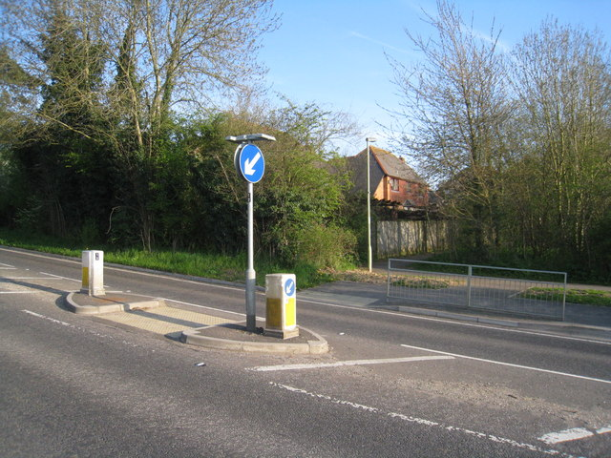](http://www.google.co.uk/url?sa=i&rct=j&q=&esrc=s&source=images&cd=&cad=rja&uact=8&ved=2ahUKEwiXx8_lzr7aAhVBuRQKHcQmDpwQjRx6BAgAEAU&url=http://www.geograph.org.uk/photo/1821490&psig=AOvVaw0Mo65EySs93HcOV84ZmxsO&ust=1523961937862510)[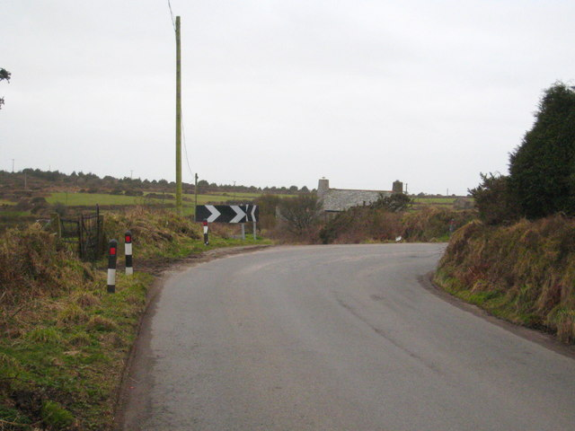](http://www.google.co.uk/url?sa=i&rct=j&q=&esrc=s&source=images&cd=&cad=rja&uact=8&ved=2ahUKEwjS5_-Dz77aAhVIsBQKHWVhAH0QjRx6BAgAEAU&url=http://www.geograph.org.uk/photo/2260187&psig=AOvVaw1bsirqfnmuEbD9MrlhTu83&ust=1523961998134317)