Tick the correct word missing from the sentence. | Use the pictures to work out the answer
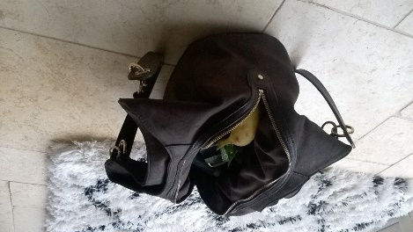  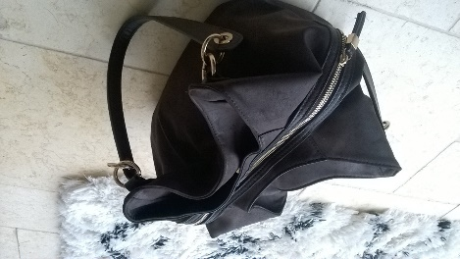  Always make sure your bag is ……………... and you can see it.  □ Done up  □ Open | You should keep valuables like your …………. Hidden in your bag  Don’t carry too much ……………. in your ……………... or purse.  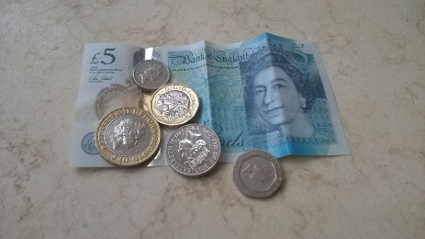  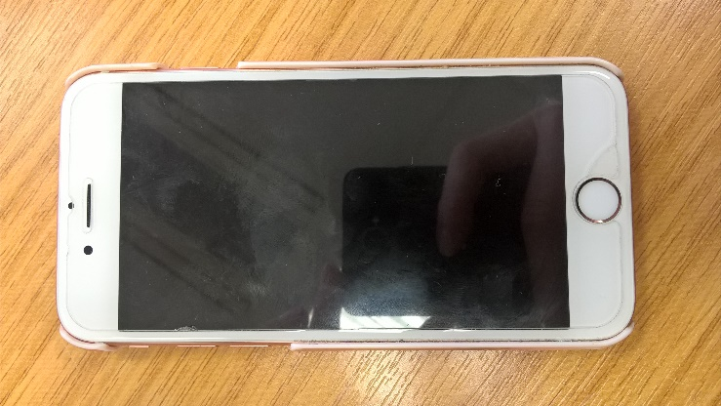  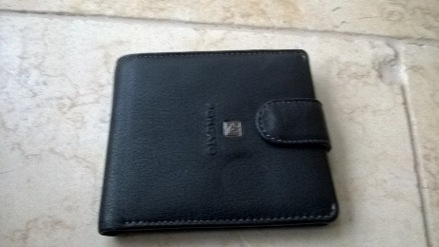
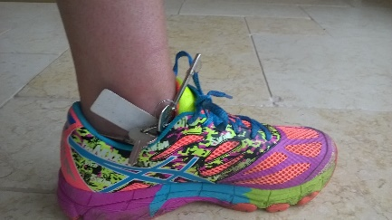
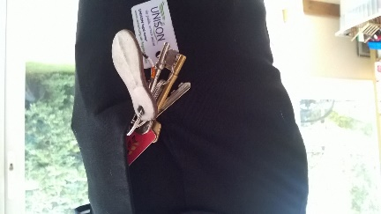
Keep your keys safe in your ……………………
□ Shoe

□ Pocket

□ Hands

