Travel Awareness Survey
In small groups investigate a road local to your school to identify risks.
Talk results through with the other teams
Where is the safest place to cross the road?

Area Surveyed |  | Yes   | No  x
Parked Cars?  Is there a risk to crossing where parked cars are situated?  Is there somewhere else to cross? | 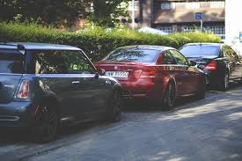
Road Markings?  Are the road markings clear to cars and pedestrians? | 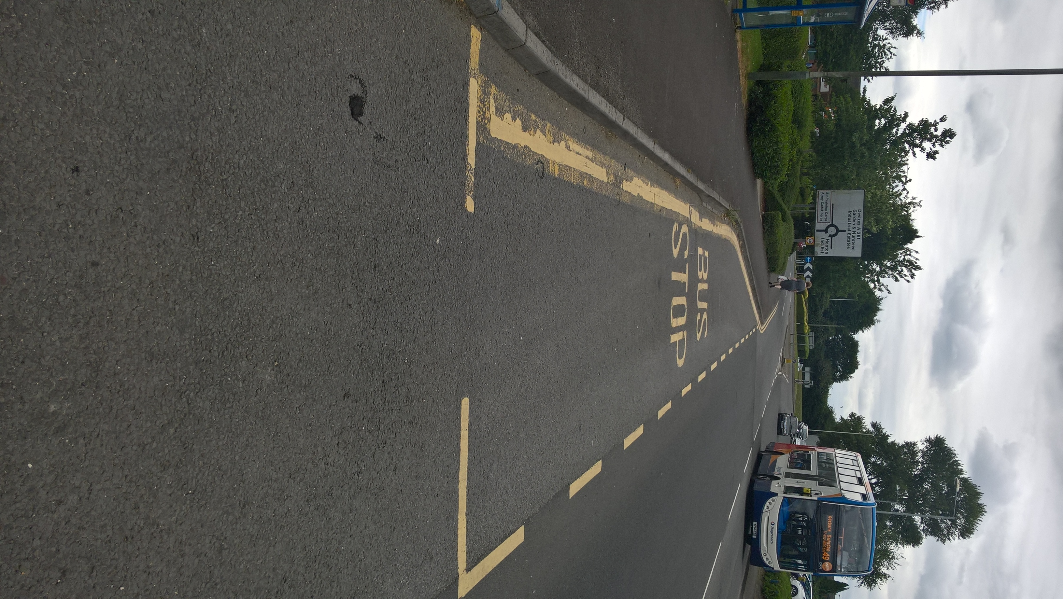
Uneven ground?  Is the ground safe to walk on? | 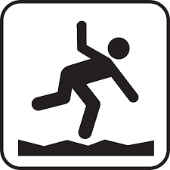
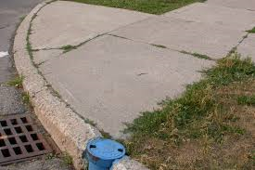
High Kerbs?
Can you find a dropped kerb?
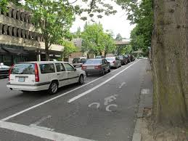
Moving Cars/stationary cars?
Can you see movement, exhaust fumes? Are there people in the stationary car, can you see the indicators flashing?
Weather?  Is it suitable to be travelling?  Are you wearing appropriate clothing? | 

