Think about the following situations and then discuss with a classmate
How would you ask the bus driver for a ticket? | Who can you ask for help if you get lost or get on the wrong bus?
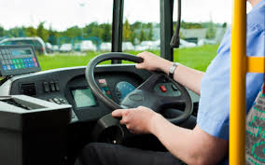  □ Do you know where you are going?  □ Do you need a return ticket?  □ Do you have a bus pass?  □ Do you know how much it will cost? | □ Do you know how to use a mobile phone?  □ Do you know your emergency number?

