Help us improve the local footpaths in [VILLAGE]

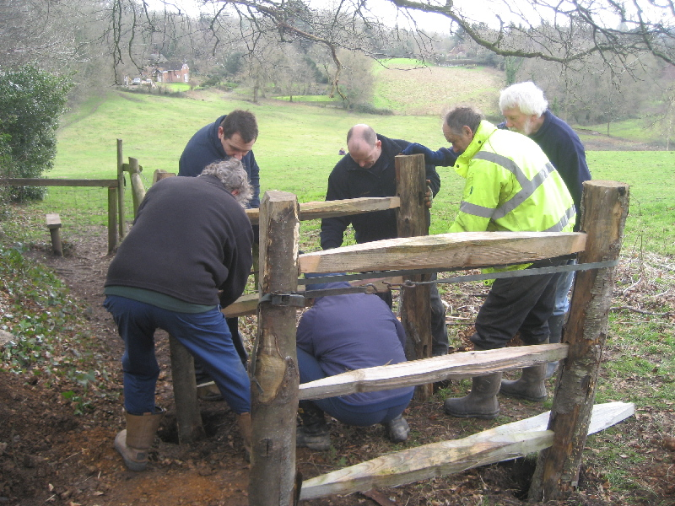
About the event:
[What the main goal? What do volunteers need to bring? Etc. ]

[Event date] [Event time]
[Venue/meeting place]
[Contact person/details]

